**Lab Report No 3**



**Digital Signal Processing**

**Submitted By:** Hassan Zaib Jadoon

**Registration No:** 22pwcse2144

**Section:** A

“On my honor, as student of University of Engineering and Technology, I have neither given nor received unauthorized assistance on this academic work”

Student Signature: ___________________________

**Department of Computer Systems Engineering**

**University of Engineering and Technology Peshawar**

**CSE 402L: Digital Signal Processing**

|  |  |  |  |  |
| --- | --- | --- | --- | --- |
| **Demonstration of Concepts** | **Poor (Does not meet expectation (1))**  The student failed to demonstrate a clear understanding of the assignment concepts | **Fair (Meet Expectation (2-3))**  The student demonstrated a clear understanding of some of the assignment concepts | **Good (Exceeds Expectation (4-5)**  The student demonstrated a clear understanding of the assignment concepts | **Score**  **30%** |
| **Accuracy** | The student completed ( <50%) tasks and provided MATLAB code and/or Simulink models with errors. Outputs shown are not correct in form of graphs (no labels) and/or tables along with incorrect analysis or remarks. | The student completed partial tasks (50% - <90%) with accurate MATLAB code and/or Simulink models. Correct outputs are shown in form of graphs (without labels) and/or tables along with correct analysis or remarks. | The student completed all required tasks (90%-100%) with accurate MATLAB code and/or Simulink models. Correct outputs are shown in form of labeled graphs and/or tables along with correct analysis or remarks. | **30%** |
| **Following Directions** | The student clearly failed to follow the verbal and written instructions to successfully complete the lab | The student failed to follow the some of the verbal and written instructions to successfully complete all requirements of the lab | The student followed the verbal and written instructions to successfully complete requirements of the lab | **20%** |
| **Time Utilization** | The student failed to complete even part of the lab in the allotted amount of time | The student failed to complete the entire lab in the allotted amount of time | The student completed the lab in its entirety in the allotted amount of time | **20%** |

**Lab No: 3.**

## **Title: Spectral Analysis of a random signal using MATLAB**

**Provide .m file with detailed comments**

Hint: Find Power Spectral Density, a measurement of the energy at various frequencies,

1. First, create some data. Consider data sampled at 1000 samples/sec. Start by forming a time axis for the data, running from t=0 until t=.25 in steps of 1 millisecond. Then form a signal, x, containing sine waves at 50 Hz and 120 Hz.

(Hint: x = sin(2*pi*50*t) + sin(2*pi*120*t);)

Code Screenshot:

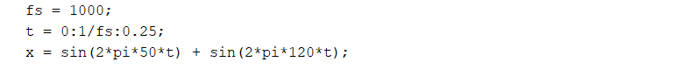

Comments: We created a time axis from 0 to 0.25 seconds of 1 steps, that generated a signal with 50 Hz and 120 Hz sine waves.

1. Add some random noise with a standard deviation of 2 to produce a noisy signal y. Take a look at this noisy signal y by plotting it. (Hint: y = x + randn(size(t));)

Code Screenshot:

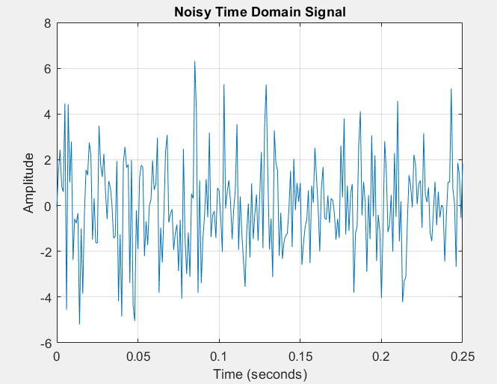

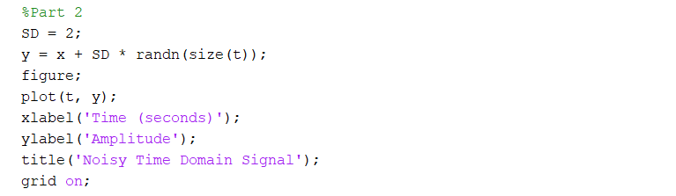

Comments: Here we are adding random noise with a standard deviation of 2 to the signal and plotting the resulting noisy signal, y.

1. Finding the discrete Fourier transform of the noisy signal y (Hint: Y = fft(y,251);)

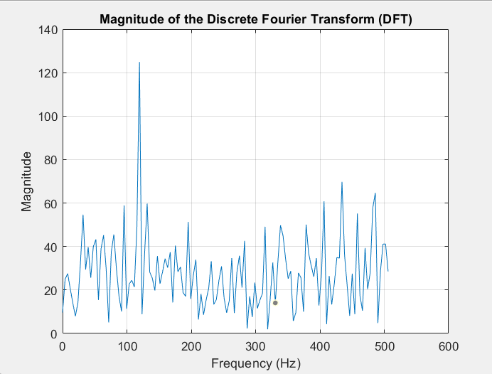Code Screenshot:

Remarks: Here we are finding the discrete Fourier transform of the noisy signal y using 251 points.

1. Compute the power spectral density, a measurement of the energy at various frequencies, using the complex conjugate (CONJ). Form a frequency axis for the first 127 points and use it to plot the result.  (Hint: Pyy = Y.*conj(Y)/251; f = 1000/251*(0:127);)

Code Screenshot:

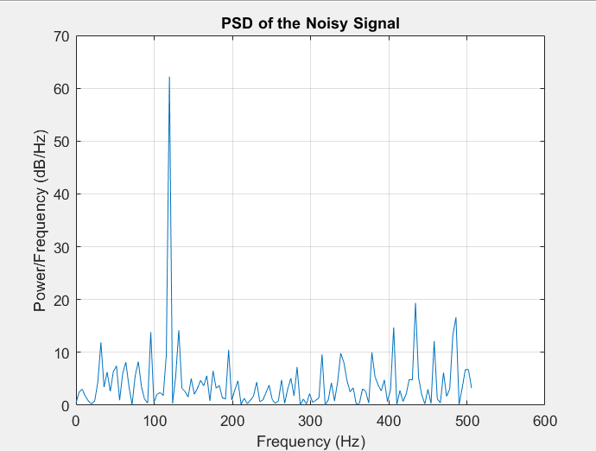

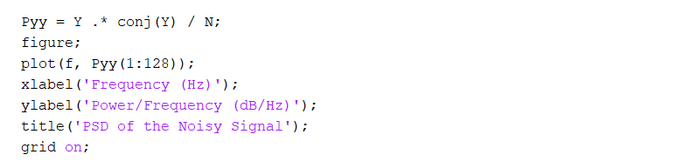

Remarks: Calculating the power spectral density of y and creating a frequency axis for the first 127 points, and plotting the result.

1. Compute and plot the periodogram using periodogram. Show that the two results are identical.

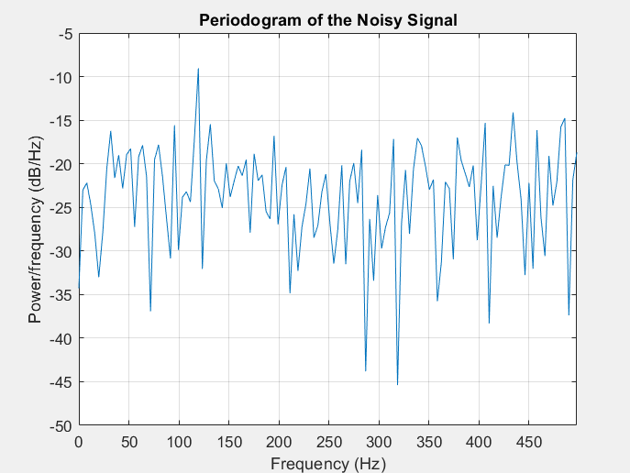Code Screenshot:

Remarks: Computing and plotting the periodogram of y and comparing it to the power spectral density to show they are identical.

1. Zoom in and plot only up to 200 Hz. Notice the peaks at 50 Hz and 120 Hz. These are the frequencies of the original signal. ( Hint: plot(f(1:50),Pyy(1:50))

Code:

Remarks: Zooming in on the plot up to 200 Hz to highlight peaks at 50 Hz and 120 Hz and showing the original signal frequencies.